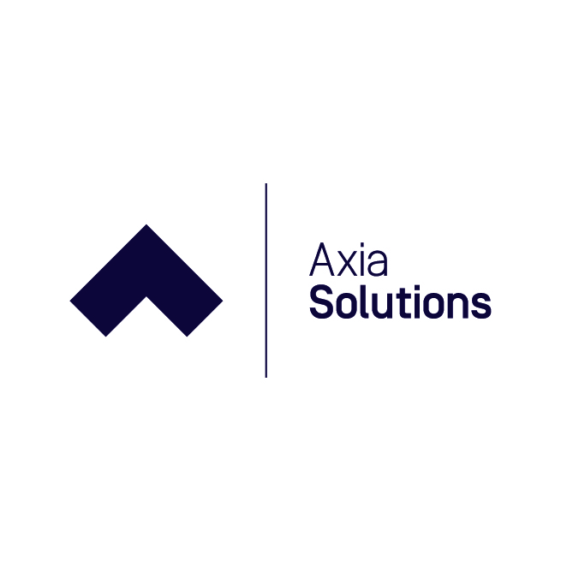

Safeguarding and Child Protection Policy

Axia Solutions Ltd delivers work-based training solutions which are funded by employers and government agencies.

Policy Statement
Axia is strongly committed to practices that protect children, young people and vulnerable adults from abuse, neglect or significant harm. Staff recognise and accept their responsibility to develop the awareness of the risks and issues involved in safeguarding. The company also recognises that it has a responsibility to protect staff from unfounded allegations of abuse. We are committed to working with existing local safeguarding or adult safeguarding Boards and other health and social care partnerships to ensure the safeguarding of our learners.

Definition
For the purpose of this policy and procedure, children are defined in the Children Act of 1989 as individuals under the age of 18 years. The Safeguarding Vulnerable groups Act of 2006 defines a ‘vulnerable adult’ as a person aged 18 and over who is:

- Receiving a social care service
- Receiving a health service
- Living in sheltered accommodation
- Detained in custody or under a probation order
- Requiring assistance in the conduct of his/her affairs
- Receiving a service or participating in an activity targeted at older people, individuals with disabilities or with physical or mental conditions.

If a vulnerable adult alleges that abuse has taken place, contact will be made with his/her social worker, next of kin or advocate, as appropriate. Furthermore, the individual will be supported throughout the investigation and a plan put into place that does not place him/her at further risk of abuse or harm.

Recruitment and Training
Safe recruitment practices and processes ensure that every precaution is taken in the selection of new staff who will have contact with children and vulnerable adults. Axia has a duty to promote safeguarding issues and measures to staff to ensure that they:

- Analyse their own practice against established good practice and assess risk to ensure they are protected from false allegations.
- Recognise their responsibilities and report any concerns about suspected poor practice or possible abuse (Code of Conduct)
- Undertake regular safeguarding training to raise awareness of current issues and legislation. Staff have a good understanding of harm and abuse and of what is considered appropriate and inappropriate physical contact with learners

Accountability and Responsibility
Axia has a trained Safeguarding Lead (SL), Yvonne Licata, from the senior management team. Incidents or concerns reported to staff, all of whom have received safeguarding training, are referred to the Safeguarding Officer who can be contacted on 01782 572777 . Our role is to identify and report any suspected abuse, support any child or vulnerable adult making an allegation of abuse and to provide them with a safe environment.

Disclosure and Barring Service Checking
We have a responsibility to ensure safe recruitment and employment practices under the Keeping Children Safe in Education 2019 statutory guidance. Staff are checked through the Home Office via an enhanced DBS check with new recruits being checked prior to coming into contact with learners.

Statutory Framework
Axia aims to meet legislative requirements and good practice within safeguarding. The statutory framework under which we operate includes The Children Act 1989, which provides for the protection of children and young people in the UK. The Protection of Children Act 1999 requires employers to carry out DBS checks before employees come into contact with children. The Safeguarding Vulnerable Groups Act 2006 seeks to regulate and control activity of employers and other agencies in relation to children and vulnerable adults. Ofsted inspectors now make judgments on procedures for safeguarding learners and the extent to which they meet government requirements.

Axia solutions use the Stoke-on-Trent and Staffordshire Local Authority Safeguarding Children’s Board template to ensure compliance with local authority policy. Should a learners registered with Axia living outside of the local authority be deemed to be at risk Axia would liaise with SSCB to ensure compliance with out of area LA frameworks.

Review
Axia’s Safeguarding Policy is reviewed annually, taking into account feedback from learners, employers, staff and other stakeholders to determine the impact of the policy and actions required.

Axia solutions liaises regularly with Lesley Morrey the Safeguarding Lead at NSCG (Axia’s parent company) who cascades updates to Axia’s SL and DSL and supports staff CPD.

Paula Rowland
Managing Director

